**Task 02**



Spring 2022

CSE-307 Microprocessor Based system Design

Submitted by: **Ashfaq Ahmad**

Registration No: **19PWCSE1795**

Class Section: **B**

“On my honor, as student of University of Engineering and Technology, I have neither given nor received unauthorized assistance on this academic work.”

Student Signature: ______________

Submitted to:

**Dr: Bilal Habib**

**April** 17, 2022

**Department of Computer Systems Engineering**

**University of Engineering and Technology, Peshawar**

**Task 01:**

1. Generate a signal on pin P1.2 having a frequency equal to 200 Hz with a duty cycle of 40%.
2. When a user presses a button at P1.1 the frequency changes to 100Hz with a 60% duty cycle.
3. Show it on an oscilloscope. Use only Proteus.
4. Each time a user presses a button the signal toggles from A to B and then B to A on the next subsequent press.

**Problem Analysis:**

**Case A:**

* To generate a signal on pin P1.2 having a frequency equal to 200 Hz, we need 1/200 time period >> T=5ms
* As duty cycle is 40% so,

>>P1.2 will on for 2ms.

>>P1.2 will off for 3ms.

**Case B:**

* Now to generate a signal on pin P1.2 having a frequency equal to 100 Hz, we need 1/100 time period >> T=10ms
* As duty cycle is 60% so,

>>P1.2 will on for 6ms.

>>P1.2 will off for 4ms.

**Source Code:**

#include <reg51.h>

#include <stdio.h>

sbit pin=P1^2;

sbit button=P1^1;

void mysig(unsigned int msec)

{

unsigned int j,k;

for( j=0; j<msec; j++)

{

for( k=0; k<125; k ++);

}

}

void main()

{

while(1)

{

if(button)

{

pin=1;

mysig(2);

pin=0;

mysig(3);

}

else

pin=1;

mysig(6);

pin=0;

mysig(4);

}

}

**Output:**

A: When Button is not pressed:

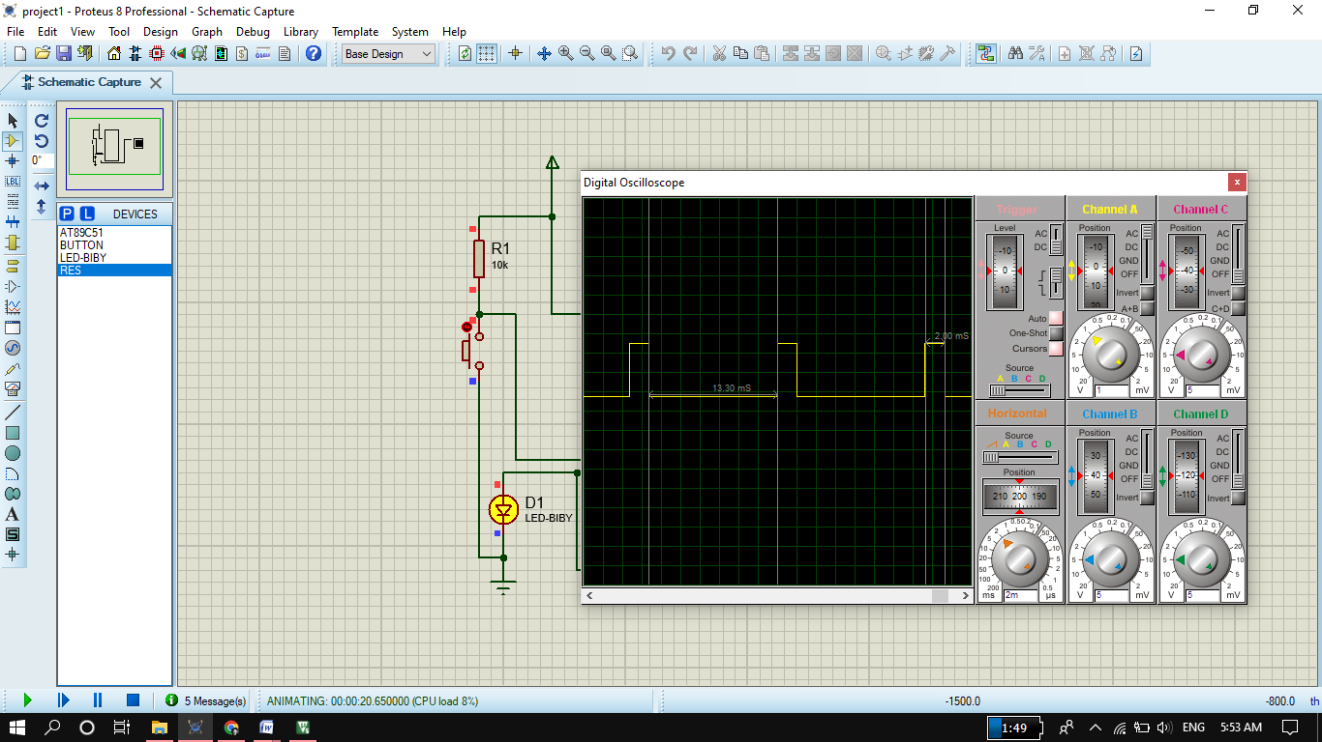

**B: when the button is pressed.**

